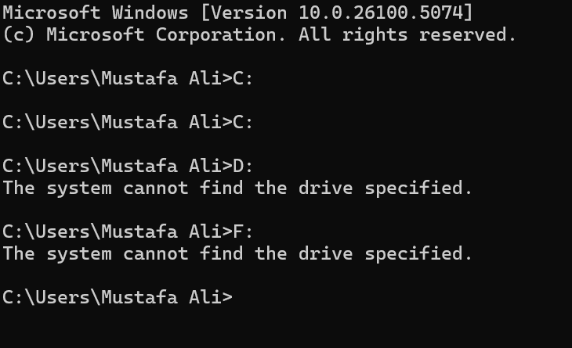

DRIVE CAN NOT BE CHANGED BECAUSE I ONLY HAVE ONE DRIVE



DIRECTORY CREATED IN C DRIVE

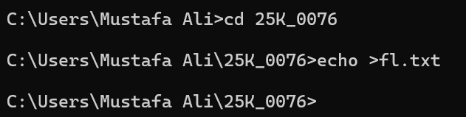

CREATED A FILE IN THAT FOLDER



ADD TEXT INTO THE FILE

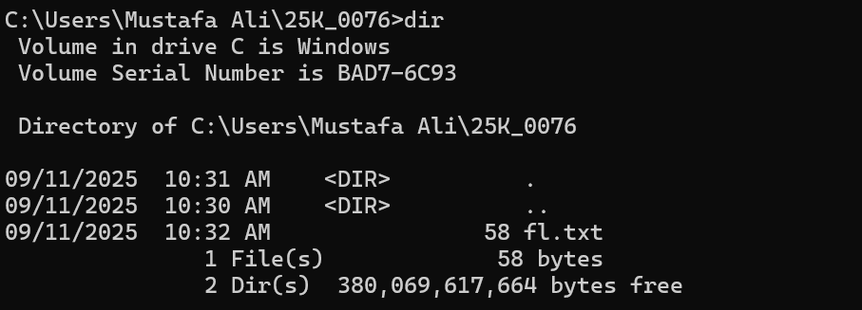

DISPLAY ALL THE FILES IN THE DIRECTORY



DISPLAY THE CONTENT IN FILES

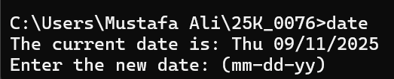

DISPLAY DATE

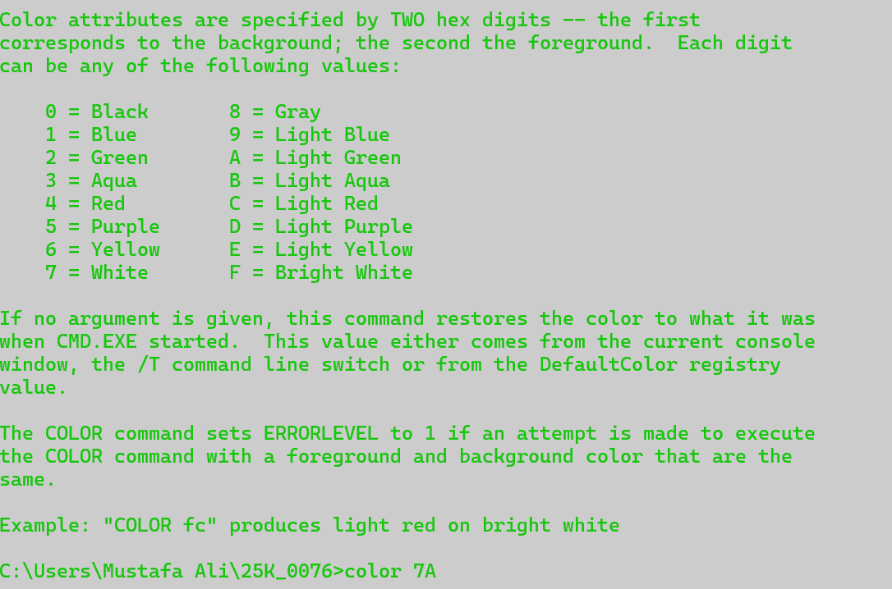

CHANGE BACKGROUND AND TEXT COLOR



CREATE NEW FILE AND COPY THE CONTENT OF F1



DELETE